Gyan Ganga Institute of Technology and Sciences, Jabalpur


Department of Computer Science and Engineering

COURSE FILE
2018-19
Dot Net

(CS-406)

Mission and Vision of the Institution:

Vision of Institute:
Initially to seek autonomy and eventually grow the Institute into a renowned University by:
- Imparting the best technical and professional education to the students of the Institute.
- Developing all the Departments of the Institute as Centers of Excellence.
- Creating the most congenial and cordial environment of Teaching, Learning and Research in the Institute.
- Conceiving world - class Education, Ethics and Employability for students in global perspective.
Mission of Institute
To explore and ensure the best environment to transform students into creative, knowledgeable, principled engineers and managers compatible with their abilities in ever-changing socio-economic and competitive scenario by:
- Imparting intensive teaching and training through latest technology
- Motivating the teachers for higher learning and innovative research activities with social services.
- Generating maximum opportunities for placement of students in National, Multi-National companies and nurturing entrepreneurship quality.
- Producing highly intellectual citizens through technical education to constitute an elegant society and meeting social challenges.

Mission and Vision of the Department:

Vision
- To be an innovative and research oriented leading education centre in computer science and engineering.
- To produce skilful and employable computer science graduates to meet upcoming social challenges with moral and ethics.
Mission
- To impart intensive, innovative teaching and training through state of art
technology for achieving excellence.
- To associate with industries for identification of social needs and seize
opportunities for software development in live training and sustainable projects of
social challenges.
- Continuous knowledge up-gradation of students, staff, faculty through research,
trainings, seminars, workshops, conferences, webinars and higher studies.
- To impart knowledge of project management, commercial viability and code of
conducts for Engineers

Program Objectives
Engineering Graduates will be able to:

- Engineering knowledge: Apply the knowledge of mathematics, science, engineeringfundamentals, and an engineering specialization to the solution of complex engineeringproblems.
- Problem analysis: Identify, formulate, review research literature, and analyze complexengineering problems reaching substantiated conclusions using first principles of mathematics,natural sciences, and engineering sciences.
- Design/development of solutions: Design solutions for complex engineering problems anddesign system components or processes that meet the specified needs with appropriateconsideration for the public health and safety, and the cultural, societal, and environmentalconsiderations.
- Conduct investigations of complex problems: Use research-based knowledge and researchmethods including design of experiments, analysis and interpretation of data, and synthesis of theinformation to provide valid conclusions.
- Modern tool usage: Create, select, and apply appropriate techniques, resources, and modernengineering and IT tools including prediction and modeling to complex engineering activitieswith an understanding of the limitations.
- The engineer and society: Apply reasoning informed by the contextual knowledge to assesssocietal, health, safety, legal and cultural issues and the consequent responsibilities relevant tothe professional engineering practice.
- Environment and sustainability: Understand the impact of the professional engineeringsolutions in societal and environmental contexts, and demonstrate the knowledge of, and needfor sustainable development.
- Ethics: Apply ethical principles and commit to professional ethics and responsibilities andnorms of the engineering practice.
- Individual and team work: Function effectively as an individual, and as a member or leaderin diverse teams, and in multidisciplinary settings.
- Communication: Communicate effectively on complex engineering activities with theengineering community and with society at large, such as, being able to comprehend and writeeffective reports and design documentation, make effective presentations, and give and receiveclear instructions.
- Project management and finance: Demonstrate knowledge and understanding of theengineering and management principles and apply these to one’s own work, as a member andleader in a team, to manage projects and in multidisciplinary environments.
- Life-long learning: Recognize the need for, and have the preparation and ability to engagein independent and life-long learning in the broadest context of technological change.

PSO : Program Specific Outcomes
PSO 1- Able to apply the knowledge gained during the course of the program from Mathematics, Science &amp; Engineering to solve computation task, and ability to understand, analyze, design and develop computer programs in the areas related to algorithms, system software, multi-media, web designing, data analytics and networking. (PO1, PO2, PO3)
PSO 2- Able to comprehend the technological advancements by lifelong learning and usage of modern tools for analysis and design of application and system software with varying complexity. (PO4, PO5, PO12)
PSO 3- Able to communicate effectively in oral and written forms with good leadership quality, team work, managerial skill to work in multi-disciplinary environment, involve in development of commercially viable projects, demonstrating the practice of professional ethics for sustainable development of society. (PO6, PO7, PO8, PO9, PO10, PO11)

COURSE OUTCOMES

Once the student has successfully completed this course, he/she will be able to:

CO1: Understand .NET framework, features of .Net framework, architecture and component of .Net framework.

CO2: Implement fundamentals & advance features of C#.#.

CO3 Create web applications using ASP.NET.

CO4: Design database centric application using ADO.NET.

CO5: Understand and implement XML, Web Services and JavaScript for design web pages in .Net framework.

List of Experiments as per the university

1. Working with call backs and delegates in C#
2. Code access security with C#.
3. Creating a COM+ component with C#.
4. Creating a Windows Service with C#
5. Interacting with a Windows Service with C#
6. Using Reflection in C#
7. Sending Mail and SMTP Mail and C#
8. Perform String Manipulation with the String Builder and String Classes and C#:
9. Using the System .Net Web Client to Retrieve or Upload Data with C#
10. Reading and Writing XML Documents with the XML Text-Reader/-Writer Class and C#
11. Working with Page using ASP .Net.
12. Working with Forms using ASP .Net
13. Data Sources access through ADO.Net
14. Working with Data readers , Transactions
15. Creating Web Application.

List of Experiments enhanced by the institute

1. Working with call backs and delegates in C#
2. Code access security with C#.
3. Creating a COM+ component with C#.
4. Creating a Windows Service with C#
5. Interacting with a Windows Service with C#
6. Using Reflection in C#
7. Sending Mail and SMTP Mail and C#
8. Perform String Manipulation with the String Builder and String Classes and C#:
9. Using the System .Net Web Client to Retrieve or Upload Data with C#
10. Reading and Writing XML Documents with the XML Text-Reader/-Writer Class and C#
11. Working with Page using ASP .Net.
12. Working with Forms using ASP .Net
13. Data Sources access through ADO.Net
14. Working with Data readers , Transactions
15. Creating Web Application.

Extended By GGITS:-

16. Understand about .NET framework, architecture, components & features of .NET framework.
17. Write a C# program to implement class & object
18. Write a C# program to implement single inheritance
19. Write a C# program to implement polymorphism
20. Write a C# program to implement method overriding
21. Write a C# program to demonstrate the use of base keyword
22. Write a C# program to implement abstract classes
23. Write a C# program to implement interface
24. Write a C# program to implement array
25. Write a C# program to implement stack
26. Write a C# program to implement queue
27. Implement varius controls in winows forms

.

Schedule of Practical List Performed
Sno | Name of Experiment | Unit | Type of Exp. | Cat. | CO | PO | PSO |  | Batch (A)  Covered  Date | Batch (B)  Covered  Date | Sign
1 | Working with call backs and delegates in C# | 2 | Program | Core | CO2 | PO3 | PSO1
2 | Code access security with C#. | 2 | Program | Core | CO2 | PO3 | PSO1
3 | Creating a COM+ component with C#. | 2 | Program | Core | CO2 | PO3,PO4 | PSO1,PSO2
4 | Creating a Windows Service with C# | 2 | Program | Core | CO2 | PO3 | PSO1
5 | Interacting with a Windows Service with C# | 2 | Program | Core | CO2 | PO3,PO4 | PSO1,PSO2
6 | Using Reflection in C# | 2 | Program | Core | CO2 | PO3 | PSO1
7 | Sending Mail and SMTP Mail and C# | 2 | Program | Core | CO2 | PO3,PO5 | PSO1,PSO2
8 | Perform String Manipulation with the String Builder and String Classes and C#: | 2 | Program | Core | CO2 | PO3 | PSO1
9 | Using the System .Net Web Client to Retrieve or Upload Data with C# | 4 | Program | Core | Co5 | PO3,PO12 | PSO1,PSO2
10 | Reading and Writing XML Documents with the XML Text-Reader/-Writer Class and C# | 5 | Program | Core | Co5 | PO3,PO12 | PSO1,PSO2
11 | Working with Page using ASP .Net. | 3 | Program | Core | CO4 | PO3,PO12 | PSO1,PSO2
12 | Working with Forms using ASP .Net | 3 | Program | Core | CO4 | PO3,PO12 | PSO1,PSO2
13 | Data Sources access through ADO.Net | 3 | Program | Core | CO5 | PO3,PO12 | PSO1,PSO2
14 | Working with Data readers , Transactions | 4 | Program | Core | CO5 | PO3,PO12 | PSO1,PSO2
15 | Creating Web Application. | 3 | Program | Core | CO4 | PO3 | PSO1
16 | Understand about .NET framework, architecture, components & features of .NET framework | 1 | Study | Core | CO1 | PO5,PO12 | PSO1,PSO2
17 | Write a C# program to implement class & object | 2 | Program | Core | CO2 | PO3,PO12 | PSO1,PSO2
18 | Write a C# program to implement single inheritance | 2 | Program | Core | CO2 | PO3,PO12 | PSO1,PSO2
19 | Write a C# program to implement polymorphism | 2 | Program | Core | CO2 | PO3,PO12 | PSO1,PSO2
20 | Write a C# program to implement method overriding | 2 | Program | Core | CO2 | PO3,PO12 | PSO1,PSO2
21 | Write a C# program to demonstrate the use of base keyword | 2 | Program | Core | CO2 | PO3,PO12 | PSO1,PSO2
22 | Write a C# program to implement abstract classes | 2 | Program | Core | CO2 | PO3,PO12 | PSO1,PSO2
23 | Write a C# program to implement interface | 2 | Program | Core | CO2 | PO3,PO12 | PSO1,PSO2
24 | Write a C# program to implement array | 2 | Program | Core | CO2 | PO3,PO12 | PSO1,PSO2
25 | Write a C# program to implement stack | 2 | Program | Core | CO2 | PO3,PO12 | PSO1,PSO2
26 | Write a C# program to implement queue | 2 | Program | Core | CO2 | PO3,PO12 | PSO1,PSO2
27 | Write a C# program to implement varius controls in winows forms | 3 | Program | Core | CO2 | PO3,PO12 | PSO1,PSO2

Experiment-01
AIM : Working with call backs and delegates in C#

ABOUT THE EXPERIMENT: C# delegates are similar to pointers to functions, in C or C++. A delegate is a reference type variable that holds the reference to a method. The reference can be changed at runtime.
Delegates are especially used for implementing events and the call-back methods. All delegates are implicitly derived from the System.Delegate class.

Declaring Delegates
Delegate declaration determines the methods that can be referenced by the delegate. A delegate can refer to a method, which has the same signature as that of the delegate.
For example, consider a delegate −
public delegate int MyDelegate (string s);
The preceding delegate can be used to reference any method that has a single string parameter and returns an int type variable.
Syntax for delegate declaration is −
delegate <return type> <delegate-name> <parameter list>

Software Used: Visual Studio.Net

PROGRAM CODE:
using System;
delegate int NumberChanger(int n);
namespace DelegateAppl {
class TestDelegate {
static int num = 10;
public static int AddNum(int p) {
num += p;
return num;
}
public static int MultNum(int q) {
num *= q;
return num;
}
public static int getNum() {
return num;
}
static void Main(string[] args) {
//create delegate instances
NumberChanger nc1 = new NumberChanger(AddNum);
NumberChanger nc2 = new NumberChanger(MultNum);
//calling the methods using the delegate objects
nc1(25);
Console.WriteLine("Value of Num: {0}", getNum());
nc2(5);
Console.WriteLine("Value of Num: {0}", getNum()); Console.ReadKey();
}
}
}

Experiment-02
AIM : Code access security with C#

ABOUT THE EXPERIMENT: Security is an essential part of an application and it should be taken into consideration from the grass-roots level of an application's design. Security is all about protecting your assets from unauthorized actions.
But Code Access Security (CAS) is a feature of .NET CLR that enables you to control the permissions that an individual .NET application has on your system during its execution. As a developer, you must understand how to create applications that work, even when some permission is restricted or to restrict your application from performing certain tasks, for example, a user can't delete/create a file in the "C:\Windows" directory.
Security Model
When you perform some action on the user interface, such as click a button, your application connects to the internet, downloads the modules into the Download Assembly Cache, and begins executing. Behind the scenes, what evidence do you actually have that you can trust the code your computer is downloading?
.NET enforces security polices around assemblies. It uses the evidence that an assembly has, such as the origination of the file. The runtime places all code from the local intranet into a specific group. It then uses the security policies to decide what permissions the code should be granted at a granular level.
MSIL Verification
When .NET code is compiled, the output it produces is an intermediate language (IL) code that requires a runtime to execute the IL. So during assembly load at runtime, it first validates the metadata then examines the IL code against this metadata to see that the code is type safe. When MSIL code is executed, it is compiled Just-in-Time and converted into a platform-specific code that's called native code.
Thus any code that can be converted to native code is valid code. Code that can't be converted to native code due to unrecognized instructions is called Invalid code. During JIT compilation the code is verified to see if it is type-safe or not.
To determine whether your code is verifiably type safe, you can use the "peverify" utility at the .NET command prompt as in the following;
peverify ConsoleApplication1.exe
After executing the aforementioned command, you will get the following output:
All classes and Methods in ConsoleApplication1.exe Verified
Code Access Security
Code Access Security enables users to restrict, on a very granular level, what managed code can do according to a level of trust. If the CLR trusts the code enough to allow it to run then it will begin executing the code depending on the permissions given to the assembly. If the code is not trusted and attempts to perform some action it does not have relevant rights for then a security exception is thrown.
It is important to understand that code access security is about protecting resources, such as directories, local drives, event logs, user interface and the network from malicious code. It is not primarily a tool for protecting software from users.
Code Access Security can be applied only to managed applications. Unmanaged applications run without any CAS restrictions and are limited only by the operating system's role-based security. If CAS is used to restrict the permissions of an assembly then the assembly is considered partially trusted. Partially trusted assemblies must undergo CAS permission checks each time they access a protected resource. Fully trusted assemblies, like unmanaged code, can access any system resource that the user has permissions to access
Elements of Code Access Security
Every security system needs some sort of mechanism (such as user name, password and Access Control List (ACL)) to identify the users and determine what a user can or can't do. However CAS identifies and assigns permissions to application rather than to application users.
CAS identifies assemblies using evidence, there are a few elements by which an assembly can be identified, such as location, hash code and signature of the assembly. Evidence is the information that the runtime gathers about an assembly to determine which code group the assembly belongs to. Code groups in turn grant an assembly a permission set.
Components Of Code Access Security
Code Group
The evidence provided by an assembly is used as the condition for granting and revoking permissions to it. It is done by putting the code in an appropriate code group. Every code group stipulates a membership condition and has specific conditions attached to it. Any assemblies that meet the condition become a member of the group. Code groups are arranged in a hierarchy and assemblies are nearly always matched to several code groups. The code group at the root of the hierarchy is called All Code and contains all other code groups.
Evidence
In order for the CLR to determine which code group to place assembly information into, the first step is to read supplied evidence. There are two main sources of information, they are internet and intranet. The group internet defines code that is sources from the internet and the group intranet defines code sources from a LAN. The examination of the assembly evidence makes the authentication part of the security process. The following table depicts the major type of evidence an assembly can present to the CLR.
Evidence | Description
Zone | The region such as intranet, local, trusted from which the code originated.
URL | The specific URL from which the code originated.
Strong Name | Unique verifiable name for the code.
Site | The website from which the code originated.
Harsh Value | The hash value of the assembly contents.
Publisher | The assembly digital signature that uniquely identified the developer.
Application Directory | The directory in which assembly resides.
Permissions
Permissions are the actions you allow each code group to perform. The system administrator usually manages the permissions at the enterprise, machine and user levels. The CLR Virtual Execution System (VES) loads and runs programs. It provides the functionality required to execute managed code and uses assembly metadata to connect modules together at runtime. When VES loads an assembly, it matches the assembly to one or more code groups. Each code group is assigned to one or more permissions that specify what actions assemblies can do in that code group.
Note: mscorcfg.msc is no more a part of .NET 4.0; you can use caspol.exe instead to do the same work.
Permissions Sets are unique combinations of security configurations that determine what each user with access to a machine can do on that machine. There are several permission sets shipped with the .NET Framework as in the following table:
Permission | Description
FullTrust | Allow full access to all resources.
Everything | Allow full access to all resources (group isn't added to assembly list)
Internet | Grant Default rights.
SkipVerification | Bypass all security verification
Nothing | Denies all access including Execution
Execution | Allows execution-only access.
We will now create simple applications that will hard-code the name of an assembly with full path to load it into memory. At this point, we will enumerate over each supplied form of assembly evidence and print the data to the console window.
To begin, the Program type provides a Main() method that allows users to enter the full path to the assembly they wish to evaluate. We will pass the Assembly reference to another helper method named DisplayEvidence(). The following is the story so far:

Software Used: Visual Studio.Net

PROGRAM CODE:
using System.Collections;
using System.Security.Policy;
using System.Reflection;
namespace SecTest
{
class Program
{
static void Main(string[] args)
{
// Load another assembly
Assembly asb = Assembly.LoadFrom(@"F:\Temp\test\test\bin\Debug\test.exe");
Console.WriteLine("***** Evidence Viewer *****\n");
if (asb != null)
{
DisplayEvidence(asb);
}
Console.ReadLine();
}
private static void DisplayEvidence(Assembly asm)
{
// Get evidence collection using enumerator.
Evidence e = asm.Evidence;
IEnumerator obj = e.GetHostEnumerator();
// Now print out the evidence.
while (obj.MoveNext())
{
Console.WriteLine(" **** Press Enter to continue ****"); Console.ReadLine();
Console.WriteLine(obj.Current); }}}}

Experiment-03

AIM : Creating a COM+ component with C#.

ABOUT THE EXPERIMENT: COM is a platform-independent, distributed, object-oriented system for creating binary software components that can interact. COM is the foundation technology for Microsoft's OLE (compound documents) and ActiveX (Internet-enabled components) technologies.
COM objects can be created with a variety of programming languages. Object-oriented languages, such as C++, provide programming mechanisms that simplify the implementation of COM objects. These objects can be within a single process, in other processes, even on remote computers.
The .NET Framework allows developers to create serviced (configured) components, which can take advantage of services offered by COM+. The most commonly used of these services include Transaction management, Just-In-Time (JIT) Activation, Synchronization, and Object Pooling. The System.EnterpriseServices namespace provides the .NET developer with access to these services. This example demonstrates how to create a COM+ component, which takes advantage of Transaction management service within COM+, assign a strong name to the assembly, register the assembly in the Global Assembly Cache, and finally register the component with COM+

Software Used: Visual Studio.Net

PROGRAM CODE:
using System;
using System.Data;
using System.Data.SqlClient;
using System.EnterpriseServices;
[Transaction(TransactionOption.Required)]
public class Customers : ServicedComponent
{
public Customers()
{
}

//code for the class
}
This class is now considered a configured class, and consequently has access to its associated context object, when it is instantiated by another application.

A look at the UpdateDetailQuantity method will show this:

public bool UpdateDetailQuantity(int OrderID, string ProductName, int Quantity)
{
SqlConnection cn = CreateConnection();
cn.Open();
try
{
if(!ContextUtil.IsInTransaction)
throw new Exception("Requires Transaction");

string CommandText = "Update [Order Details] set Quantity =
"+Quantity+" where
OrderID = "+OrderID+" AND [Order Details].ProductID IN";

CommandText+= "(Select ProductID from Products where ProductName =
'"+ProductName+"')";

SqlCommand cmd = new SqlCommand();
cmd.Connection = cn;
cmd.CommandType = CommandType.Text;
cmd.CommandText = CommandText;
cmd.ExecuteNonQuery();
ContextUtil.SetComplete();
return true;
}
catch (Exception e)
{
cn.Close();
ContextUtil.SetAbort();
return false;
}
finally
{
cn.Close()
}
}

Experiment-04

AIM : Creating a Windows Service with C#

ABOUT THE EXPERIMENT: Windows Services normally start when the OS boots. Windows Service is running an application in the background. Windows Services executes applications in its own session. It either starts automatically or we can also manually pause, stop and restart it.
Windows service is a computer program, which will run in the background.
You can find services in the following ways
- Go to Control Panel select “Services” inside “Administrative Tools”.
- Open Run window (Window + R) and type services.msc and press enter

Software Used: Visual Studio.Net

PROGRAM CODE:

using System;
using System.Collections.Generic;
using System.ComponentModel;
using System.Data;
using System.Diagnostics;
using System.IO;
using System.Linq;
using System.ServiceProcess;
using System.Text;
using System.Threading.Tasks;
namespace MyFirstWindowsService
{
public partial class TestService: ServiceBase
{
System.Timers.Timer timeDelay;
int count;
public TestService()
{
InitializeComponent();
timeDelay = new System.Timers.Timer();
timeDelay.Elapsed += new System.Timers.ElapsedEventHandler(WorkProcess);
}
public void WorkProcess(object sender, System.Timers.ElapsedEventArgs e)
{
string process = "Timer Tick " + count;
LogService(process);
count++;
}
protected override void OnStart(string[] args)
{
LogService("Service is Started");
timeDelay.Enabled = true;
}
protected override void OnStop()
{
LogService("Service Stoped");
timeDelay.Enabled = false;
}
private void LogService(string content)
{
FileStream fs = new FileStream(@ "d:\TestServiceLog.txt", FileMode.OpenOrCreate, FileAccess.Write);
StreamWriter sw = new StreamWriter(fs);
sw.BaseStream.Seek(0, SeekOrigin.End);
sw.WriteLine(content);
sw.Flush();
sw.Close();
}
}
}

Experiment-05

AIM : Interacting with a Windows Service with C#

ABOUT THE EXPERIMENT: The .NET Framework provides the ServiceController class for interacting and controlling Windows Services on a local or remote machine. An instance of the ServiceController class will allow an application to connect to and manipulate an existing service simply by providing the machine name and service name.
The following example is an application that launches a Windows Form to allow the user to interact and manipulate the IIS Admin service on the local machine. The application works by placing an icon in the System Tray.

Software Used: Visual Studio.Net

PROGRAM CODE:
var ServiceKeys = Microsoft.Win32.Registry
.LocalMachine.OpenSubKey(String.Format( @"System\CurrentControlSet\Services\{0}", ServiceName), true);
try
{
var ServiceType = (ServiceType)(int)(ServiceKeys.GetValue("type"));
//Service must be of type Own Process or Share Process
if (((ServiceType & ServiceType.Win32OwnProcess) != ServiceType.Win32OwnProcess)
&& ((ServiceType & ServiceType.Win32ShareProcess) != ServiceType.Win32ShareProcess))
{
throw new Exception("ServiceType must be either Own Process or Shared Process to enable interact with desktop");
}
var AccountType = ServiceKeys.GetValue("ObjectName");
//Account Type must be Local System
if (String.Equals(AccountType, "LocalSystem") == false)
throw new Exception("Service account must be local system to enable interact with desktop");
//ORing the InteractiveProcess with the existing service type
ServiceType newType = ServiceType | ServiceType.InteractiveProcess;
ServiceKeys.SetValue("type", (int)newType);
}
finally
{
ServiceKeys.Close();
}

Experiment-06

AIM : Using Reflection in C#

ABOUT THE EXPERIMENT:-Reflection objects are used for obtaining type information at runtime. The classes that give access to the metadata of a running program are in the System.Reflection namespace.
The System.Reflection namespace contains classes that allow you to obtain information about the application and to dynamically add types, values, and objects to the application.

Applications of Reflection
Reflection has the following applications −
- It allows view attribute information at runtime.
- It allows examining various types in an assembly and instantiate these types.
- It allows late binding to methods and properties
- It allows creating new types at runtime and then performs some tasks using those types.

Viewing Metadata
We have mentioned in the preceding chapter that using reflection you can view the attribute information.
The MemberInfo object of the System.Reflection class needs to be initialized for discovering the attributes associated with a class. To do this, you define an object of the target class, as −
System.Reflection.MemberInfo info = typeof(MyClass);

Software Used: Visual Studio.Net

PROGRAM CODE:
using System;
[AttributeUsage(AttributeTargets.All)]
public class HelpAttribute : System.Attribute {
public readonly string Url;
public string Topic // Topic is a named parameter {
get {
return topic;
}
set {
topic = value;
}
}
public HelpAttribute(string url) // url is a positional parameter {
this.Url = url;
}
private string topic;
}
[HelpAttribute("Information on the class MyClass")]
class MyClass {
}
namespace AttributeAppl {
class Program {
static void Main(string[] args) {
System.Reflection.MemberInfo info = typeof(MyClass);
object[] attributes = info.GetCustomAttributes(true);

for (int i = 0; i < attributes.Length; i++) {
System.Console.WriteLine(attributes[i]);
}
Console.ReadKey();
}
}
}

Experiment-07

AIM : Sending Mail and SMTP Mail and C#

ABOUT THE EXPERIMENT:-
SMTP (Simple Mail Transfer Protocol) is a part of the application layer of the TCP/IP protocol. It is an Internet standard for electronic mail (email) transmission. The default TCP port used by SMTP is 25 and the SMTP connections secured by SSL, known as SMTPS, uses the default to port 465.
SMTP provides a set of protocol that simplify the communication of email messages between email servers. Most SMTP server names are written in the form "smtp.domain.com" or "mail.domain.com": for example, a Gmail account will refer to smtp.gmail.com. It is usually used with one of two other protocols, POP3 or IMAP, that let the user save messages in a server mailbox and download them periodically from the server.
The Microsoft .NET framework provides two namespaces, System.Net andSystem.Net.Sockets for managed implementation of Internet protocols that applications can use to send or receive data over the Internet . SMTP protocol is using for sending email from C#. SMTP stands for Simple Mail Transfer Protocol . C# using System.Net.Mail namespace for sending email . We can instantiate SmtpClient class and assign the Host and Port . The default port using SMTP is 25 , but it may vary different Mail Servers

Software Used: Visual Studio.Net

PROGRAM CODE:-
using System;

using System.Windows.Forms;

using System.Net.Mail;

namespace WindowsApplication1

{

public partial class Form1 : Form

{

public Form1()

{

InitializeComponent();

}

private void button1_Click(object sender, EventArgs e)

{

try

{

MailMessage mail = new MailMessage();

SmtpClient SmtpServer = new SmtpClient("smtp.gmail.com");

mail.From = new MailAddress("your_email_address@gmail.com");

mail.To.Add("to_address");

mail.Subject = "Test Mail";

mail.Body = "This is for testing SMTP mail from GMAIL";

SmtpServer.Port = 587;

SmtpServer.Credentials = new System.Net.NetworkCredential("username", "password");

SmtpServer.EnableSsl = true;

SmtpServer.Send(mail);

MessageBox.Show("mail Send");

}

catch (Exception ex)

{

MessageBox.Show(ex.ToString());

}

}

}

}

Experiment-08

AIM : Perform String Manipulation with the String Builder and String Classes and C#:
ABOUT THE EXPERIMENT:-
String
A string is a sequential collection of Unicode characters that is used to represent text. String is a class which belongs to the namespace System. String.
String Concatenation can be done using '+' opearator or String.Concat method.
String.Concat method concatenates one or more instances of String.

Software Used: Visual Studio.Net

PROGRAM CODE:-
using System;
namespace StringApplication {
class Program {
static void Main(string[] args)
//from string literal and string concatenation
string fname, lname;
fname = "Rowan";
lname = "Atkinson";

string fullname = fname + lname;
Console.WriteLine("Full Name: {0}", fullname);
//by using string constructor { 'H', 'e', 'l', 'l','o' };
string greetings = new string(letters);
Console.WriteLine("Greetings: {0}", greetings);
//methods returning string { "Hello", "From", "Tutorials", "Point" };
string message = String.Join(" ", sarray);
Console.WriteLine("Message: {0}", message);
//formatting method to convert a value
DateTime waiting = new DateTime(2012, 10, 10, 17, 58, 1);
string chat = String.Format("Message sent at {0:t} on {0:D}", waiting);
Console.WriteLine("Message: {0}", chat);
}
}
}

Experiment-09

AIM : Using the System .Net Web Client to Retrieve or Upload Data with C#

ABOUT THE EXPERIMENT:-
The System.Net.WebClient class provides functionality to upload data to or download data from the Internet or intranet or a local file system. The WebClient class provides many ways to download and upload data. The following table describes WebClient class methods and properties briefly.
Member | Type | Description
BaseURI | Property | Current base URL address
Headers | Property | Headers in the form of name and value pair associated with the request.
QueryStrings | Property | Queries in the form of name and value pair associated with the request.
ResponseHeaders | Property | Headers in the form of name and value pair associated with the response.
DownloadData | Method | Download data from a URI and returns data as a byte array.
DownloadFile | Method | Download data from a URI and saves as a local file.
OpenRead | Method | Opens and reads a URI in stream form.
OpenWrite | Method | Opens a stream to write data to a URI.
UploadData | Method | Uploads data buffer to a URI.
UploadFile | Method | Uploads a local file to the given URI.
UploadValues | Method | Uploads name and value collection.
Using WebClient Class
Downloading Data
The WebClient provides three different methods to download data either from the Internet, intranet, or local file system.
WebClient constructor doesn't take any arguments. In the following code, URL is the file name you want to download such as http://www.c-sharpcorner.com/index.asp. You can download any type of files using these methods such as image files, html and so on.
string URL = textBox1.Text;
WebClient client = new WebClient();
The DownloadData method takes URI as a parameter, downloads data from a resource URI and returns a byte string.
byte [] bytedata = client.DownloadData(URL);
The DownloadFile method downloads data from a resource and saves it to the local file system. Hence it takes parameters, first is URI name and second is the file name stored as on the local system. The following code downloads a URL and saves it as temp.asp.
client.DownloadFile(URL, "C:\\temp.asp");
The OpenRead method downloads data from a resource and return data as a stream.
Stream data = client.OpenRead(URL);
Software Used: Visual Studio.Net

PROGRAM CODE:-
// Address of URL
string URL = textBox1.Text;
try
{
// Get HTML data
WebClient client = new WebClient();
Stream data = client.OpenRead(URL);
StreamReader reader = new StreamReader(data);
string str = "";
str = reader.ReadLine();
while( str != null)
{
Console.WriteLine(str);
str = reader.ReadLine();
}
data.Close();
}
catch(WebException exp)
{
MessageBox.Show(exp.Message, "Exception");
}
Upload Data
The WebClient class provides four different ways to uploading data to a resource.
The OpenWrite method sends a data stream to the resource. It's reverse operation of OpenRead method. You pass URI as first parameter of OpenWrite.
OpenWrite(string);
The UploadData method sends a byte array to the resource and returns a byte array containing any response. It's a reverse operation of DownloadData method. It takes two arguments of string and array of bytes respectively.
UploadData(string, byte[]);
client.UploadData("http://www.mindcracker.com/testfile.bmp", data);
The UploadFile method sends a local file to the resource and returns a byte array containing any response. It's a reverse operation of DownloadFile. UploadFile also takes two parameters. First a URI name and second file to be uploaded.
UploadFile(string string);
client.UploadFile("http://www.mindcracker.com/tst.gif", @"c:\mcb.gif");
Or:
client.UploadFile("http://www.mindcracker.com/test.htm", @"c:\test.htm");
The UploadValues sends a NameValueCollection to the resource and returns a byte array containing any response.
UploadValues(string, NameValueCollection);
Using WebRequest and WebResponse Classes
Although you can use WebClient class to upload and download data but there are more things involved in uploading and downloading data. What if you don't have right to upload to the server you are uploading to? Did you see us passing userid and passwords for the server somewhere? We didn't think so. So if you don't have permission to write to the server, you get this error.
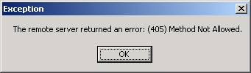
So what we do now? That's where boundary of the WebClient class ends. And that's where the WebRequest and WebResponse classes come in the existence.
The WebRequest Class
The WebRequest is an abstract base class. So you actually don't use it directly. You use it through it derived classes - HttpWebRequest and FileWebRequest.
You use Create method of WebRequest to create an instance of WebRequest. GetResponseStream returns data stream. The following sample example downloads data stream from a web page.
Sample Code
using System;
using System.Net;
using System.IO;
namespace WebRequestSamp
{
/// <summary>
/// Summary description for Class1.
/// </summary>
class Class1
{
static void Main(string[] args)
{
WebRequest request = WebRequest.Create(http://www.c-sharpcorner.com/index.asp);
WebResponse response = request.GetResponse();
StreamReader reader = new StreamReader(response.GetResponseStream());
string str = reader.ReadLine();
while(str != null)
{
Console.WriteLine(str);
str = reader.ReadLine();
}
}
}
}
HttpWebRequest and HttpWebResponse classes works in same way too. Here is one sample example.
Using HttpWebRequest and HttpWebResponse Classes
HttpWebRequest request = (HttpWebRequest)WebRequest.Create (http://www.microsoft.com );
HttpWebResponse response = (HttpWebResponse)request.GetResponse();
String ver = response.ProtocolVersion.ToString();
StreamReader reader = new StreamReader(response.GetResponseStream() );
string str = reader.ReadLine();
while(str != null)
{
Console.WriteLine(str);
str = reader.ReadLine();
}

Experiment-10

AIM : Reading and Writing XML Documents with the XML Text-Reader/-Writer Class and C#

ABOUT THE EXPERIMENT:-
XML is very versatile and most commonly used data format in any applications we develop. Hence, there will be always a need to read and write xml files in our day today development tasks. Moving forward, this little article will help us understand how to read and write xml files using C# in ASP.Net.

.Netframework has packed with a class called XmlTextWriter in System.XML namespace to create xml files dynamically. Next section will help us to understand the same.
he XmlTextWriter class includes number of methods to create xml document content very easily. Consider we need to create a xml file called Employee.xml with the below data,
<?xml version="1.0" encoding="utf-8"?>
<Employees>
<Employee type="Permanent">
<ID>100</ID>
<FirstName>Satheesh</FirstName>
<LastName>Babu</LastName>
<Dept>IT</Dept>
</Employee>
</Employees>

If you see the above xml content, you can visualize it as an xml document having xml elements (Employees, Employee) or nodes with attributes (Type) and values (Satheesh). Keeping this in mind, to create the above XML document programmatically using XmlTextWriter class we need to first call WriteStartDocument() to start the document creation which emits the xml declaration. Next, you can subsequently use WriteStartElement(), WriteAttributeString() method to construct the whole document. Remember, any xml nodes created should have the matching closing nodes. This is done by calling WriteEndElement() and WriteEndDocument() methods.

Software Used: Visual Studio.Net

PROGRAM CODE:-

Writing XML files in C#
protected void Page_Load(object sender, EventArgs e)
{
XmlTextWriter xmlwriter = new XmlTextWriter(Server.MapPath("App_Data/Employee.xml"), Encoding.UTF8);
xmlwriter.Formatting = Formatting.Indented;
xmlwriter.WriteStartDocument();
xmlwriter.WriteStartElement("Employees");

xmlwriter.WriteStartElement("Employee");
xmlwriter.WriteAttributeString("type", "Permanent");
xmlwriter.WriteElementString("ID", "100");
xmlwriter.WriteElementString("FirstName", "Satheesh");
xmlwriter.WriteElementString("LastName", "Babu");
xmlwriter.WriteElementString("Dept", "IT");
xmlwriter.WriteEndElement();

xmlwriter.WriteEndElement();
xmlwriter.WriteEndDocument();
xmlwriter.Flush();
xmlwriter.Close();
}

Reading XML files in C#
Like XmlTextWriter class, the System.Xml namespace includes XmlTextReader class which can be used to read xml document. The below code reads all the text nodes from the Employee.xml file.
protected void Page_Load(object sender, EventArgs e)
{
using (XmlTextReader reader = new XmlTextReader(Server.MapPath("App_Data/Employee.xml")))
{
while (reader.Read())
{
if (reader.NodeType == XmlNodeType.Text)
{
Response.Write(reader.Value);
Response.Write("<br>");
}
}
}
}

Experiment-11
AIM : Working with Page using ASP .Net

ABOUT THE EXPERIMENT:-

Asp.net is a web framework designed and developed by Microsoft. It is used to develop websites, web applications and web services. It provides fantastic integration of HTML, CSS and JavaScript. It was first released in January 2002. It is built on the Common Language Runtime (CLR) and allows programmers to write code using any supported .NET language.
It is used to create dynamic web pages. It provides fast and lightweight way to combine server code with HTML. It helps to add video, link to the social sites. It also provides other features like you can create beautiful sites that conform to the latest web standards.
All these are stable and well equipped frameworks. We can create web applications with any of them. These are also based on the .NET Framework and share core functionalities of .NET and ASP.NET.
We can use any development style to create application. The selection of style is depends on the skills and experience of the programmer.
Although each framework is independent to other, we can combine and use any of that at any level of our application. For example, to develop client interaction module, we can use MVC and for data control, we can use Web Forms.
Software Used: Visual Studio.Net

PROGRAM CODE:-

<!-- directives -->
<% @Page Language="C#" %>

<!-- code section -->
<script runat="server">

private void convertoupper(object sender, EventArgs e)
{
string str = mytext.Value;
changed_text.InnerHtml = str.ToUpper();
}
</script>

<!-- Layout -->
<html>
<head>
<title> Change to Upper Case </title>
</head>

<body>
<h3> Conversion to Upper Case </h3>

<form runat="server">
<input runat="server" id="mytext" type="text" />
<input runat="server" id="button1" type="submit" value="Enter..." OnServerClick="convertoupper"/>

<hr />
<h3> Results: </h3>
<span runat="server" id="changed_text" />
</form>

</body>

</html>

Experiment-12

AIM : Data Source Access Using ADO.Net

ABOUT THE EXPERIMENT:-
ADO.NET Tutorial provides basic and advanced concepts of ADO.NET. Our ADO.NET Tutorial is designed for beginners and professionals both.
ADO.NET is a module of .Net Framework which is used to establish connection between application and data sources. Data sources can be such as SQL Server and XML. ADO.NET consists of classes that can be used to connect, retrieve, insert and delete data.
Our ADO.NET Tutorial includes all topics of ADO.NET Tutorial such as ADO Net Tutorial with introduction, data providers, sql server connectivity, connection, command, datareader, dataset, dataadapter, datatables, web form examples, mvc examples etc.
Software Used: Visual Studio.Net

PROGRAM CODE:-

- using System;
- using System.Data.SqlClient;
- namespace AdoNetConsoleApplication
- {
- class Program
- {
- static void Main(string[] args)
- {
- new Program().CreateTable();
- }
- public void CreateTable()
- {
- SqlConnection con = null;
- try
- {
- // Creating Connection
- con = new SqlConnection("data source=.; database=student; integrated security=SSPI");
- // writing sql query
- SqlCommand cm = new SqlCommand("create table student(id int not null,
- name varchar(100), email varchar(50), join_date date)", con);
- // Opening Connection
- con.Open();
- // Executing the SQL query
- cm.ExecuteNonQuery();
- // Displaying a message
- Console.WriteLine("Table created Successfully");
- }
- catch (Exception e)
- {
- Console.WriteLine("OOPs, something went wrong."+e);
- }
- // Closing the connection
- finally
- {
- con.Close();
- }
- }
- }
- }

Experiment-13

AIM : Creating Web Application Using Asp.net

ABOUT THE EXPERIMENT:-

Asp.net is a web framework designed and developed by Microsoft. It is used to develop websites, web applications and web services. It provides fantastic integration of HTML, CSS and JavaScript. It was first released in January 2002. It is built on the Common Language Runtime (CLR) and allows programmers to write code using any supported .NET language.
It is used to create dynamic web pages. It provides fast and lightweight way to combine server code with HTML. It helps to add video, link to the social sites. It also provides other features like you can create beautiful sites that conform to the latest web standards.
All these are stable and well equipped frameworks. We can create web applications with any of them. These are also based on the .NET Framework and share core functionalities of .NET and ASP.NET.
We can use any development style to create application. The selection of style is depends on the skills and experience of the programmer.
Although each framework is independent to other, we can combine and use any of that at any level of our application. For example, to develop client interaction module, we can use MVC and for data control, we can use Web Forms.

Software Used: Visual Studio.Net

PROGRAM CODE:-
<!-- directives -->
<% @Page Language="C#" %>

<!-- code section -->
<script runat="server">

private void convertoupper(object sender, EventArgs e)
{
string str = mytext.Value;
changed_text.InnerHtml = str.ToUpper();
}
</script>

<!-- Layout -->
<html>
<head>
<title> Change to Upper Case </title>
</head>

<body>
<h3> Conversion to Upper Case </h3>

<form runat="server">
<input runat="server" id="mytext" type="text" />
<input runat="server" id="button1" type="submit" value="Enter..." OnServerClick="convertoupper"/>

<hr />
<h3> Results: </h3>
<span runat="server" id="changed_text" />
</form>

</body>

</html>

Experiment-14

AIM : Creating Web Application Using Asp.net

ABOUT THE EXPERIMENT:-

Asp.net is a web framework designed and developed by Microsoft. It is used to develop websites, web applications and web services. It provides fantastic integration of HTML, CSS and JavaScript. It was first released in January 2002. It is built on the Common Language Runtime (CLR) and allows programmers to write code using any supported .NET language.
It is used to create dynamic web pages. It provides fast and lightweight way to combine server code with HTML. It helps to add video, link to the social sites. It also provides other features like you can create beautiful sites that conform to the latest web standards.
All these are stable and well equipped frameworks. We can create web applications with any of them. These are also based on the .NET Framework and share core functionalities of .NET and ASP.NET.
We can use any development style to create application. The selection of style is depends on the skills and experience of the programmer.
Although each framework is independent to other, we can combine and use any of that at any level of our application. For example, to develop client interaction module, we can use MVC and for data control, we can use Web Forms.

Software Used: Visual Studio.Net

PROGRAM CODE:-
<!-- directives -->
<% @Page Language="C#" %>

<!-- code section -->
<script runat="server">

private void convertoupper(object sender, EventArgs e)
{
string str = mytext.Value;
changed_text.InnerHtml = str.ToUpper();
}
</script>

<!-- Layout -->
<html>
<head>
<title> Change to Upper Case </title>
</head>

<body>
<h3> Conversion to Upper Case </h3>

<form runat="server">
<input runat="server" id="mytext" type="text" />
<input runat="server" id="button1" type="submit" value="Enter..." OnServerClick="convertoupper"/>

<hr />
<h3> Results: </h3>
<span runat="server" id="changed_text" />
</form>

</body>

</html>

Experiment-15

AIM : Understand about .NET framework, architecture, components & features of .NET framework.

ABOUT THE EXPERIMENT:-
The .Net framework is a software development platform developed by Microsoft. The framework was meant to create applications, which would run on the Windows Platform. The first version of the .Net framework was released in the year 2000.
The version was called .Net framework 1.0. The .Net framework has come a long way since then, and the current version is 4.6.1.
The .Net framework can be used to create both - Form based and Web basedapplications. Web services can also be developed using the .Net framework.
The framework also supports various programming languages such as Visual Basic and C#. So developers can choose and select the language to develop the required application. In this chapter, you will learn some basics of the .Net framework.

.Net Framework Architecture
The basic architecture of the .Net framework is as shown below.
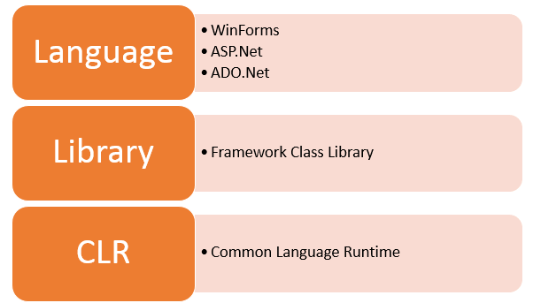
The architecture of the .Net framework is based on the following key components;
- Common Language Runtime - The "Common Language Infrastructure" or CLI is a platform on which the .Net programs are executed.
The CLI has the following key features:
- Exception Handling - Exceptions are errors which occur when the application is executed.
Examples of exceptions are:
  - If an application tries to open a file on the local machine, but the file is not present.
  - If the application tries to fetch some records from a database, but the connection to the database is not valid.
- Garbage Collection - Garbage collection is the process of removing unwanted resources when they are no longer required.
Examples of garbage collection are
  - A File handle which is no longer required. If the application has finished all operations on a file, then the file handle may no longer be required.
  - The database connection is no longer required. If the application has finished all operations on a database, then the database connection may no longer be required.
- Working with Various programming languages –
As noted in an earlier section, a developer can develop an application in a variety of .Net programming languages.
- Language - The first level is the programming language itself, the most common ones are VB.Net and C#.
- Compiler – There is a compiler which will be separate for each programming language. So underlying the VB.Net language, there will be a separate VB.Net compiler. Similarly for C#, you will have another compiler.
- Common Language Interpreter – This is the final layer in .Net which would be used to run a .net program developed in any programming language. So the subsequent compiler will send the program to the CLI layer to run the .Net application.
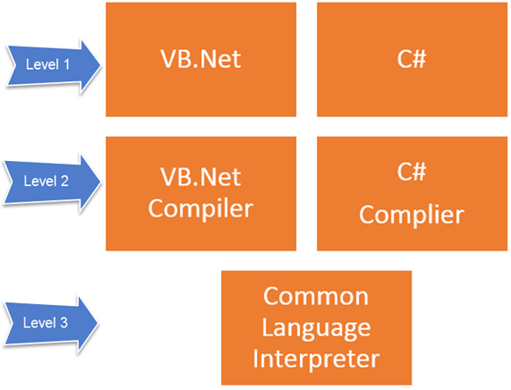
- Class Library - The .NET Framework includes a set of standard class libraries. A class library is a collection of methods and functions that can be used for the core purpose.
For example, there is a class library with methods to handle all file level operations. So there is a method which can be used to read the text from a file. Similarly, there is a method to write text to a file.
Most of the methods are split into either the System.* or Microsoft.* namespaces. (The asterisk * just means a reference to all of the methods that fall under the System or Microsoft namespace)
A namespace is a logical separation of methods. We will learn these namespaces more in detail in the subsequent chapters.
- Languages - The types of applications that can be built in the .Net framework are classified broadly into the following categories.
- WinForms – This is used for developing Forms-based applications, which would run on an end user machine. Notepad is an example of a client-based application.
- ASP.Net – This is used for developing web based applications, which are made to run on any browser such as Internet Explorer, Chrome or Firefox.
  - The Web application would be processed on a server, which would have Internet Information Services Installed.
  - Internet Information Services or IIS is a Microsoft component which is used to execute an Asp.Net application.
  - The result of the execution is then sent to the client machines, and the output is shown in the browser.
- ADO.Net – This technology is used to develop applications to interact with Databases such as Oracle or Microsoft SQL Server.
The biggest advantage of the .Net framework is that it supports Windows platform. Almost everyone works with Windows machines.
Microsoft always ensures that .Net frameworks are in compliance with all the supported Windows operating systems.
The following design principles of the .Net framework is what makes it very relevant to create .Net based applications.
- Interoperability - The .Net framework provides a lot of backward support. Suppose if you had an application built on an older version of the .Net framework, say 2.0. And if you tried to run the same application on a machine which had the higher version of the .Net framework, say 3.5. The application would still work. This is because with every release, Microsoft ensures that older framework versions gel well with the latest version.
- Portability- Applications built on the .Net framework can be made to work on any Windows platform. And now in recent times, Microsoft is also envisioning to make Microsoft products work on other platforms, such as iOS and Linux.
- Security - The .NET Framework has a good security mechanism. The in-built security mechanism helps in both validation and verification of applications. Every application can explicitly define their security mechanism. Each security mechanism is used to grant the user access to the code or to the running program.
- Memory management - The Common Language runtime does all the work or memory management. The .Net framework has all the capability to see those resources, which are not used by a running program. It would then release those resources accordingly. This is done via a program called the "Garbage Collector" which runs as part of the .Net framework.
The garbage collector runs at regular intervals and keeps on checking which system resources are not utilized, and frees them accordingly.
- Simplified deployment - The .Net framework also have tools, which can be used to package applications built on the .Net framework. These packages can then be distributed to client machines. The packages would then automatically install the application.

Experiment-16

AIM : Write a C# program to implement class & object

ABOUT THE EXPERIMENT:-
In C#, Object is a real world entity, for example, chair, car, pen, mobile, laptop etc.
In other words, object is an entity that has state and behavior. Here, state means data and behavior means functionality.
Object is a runtime entity, it is created at runtime.
Object is an instance of a class. All the members of the class can be accessed through object.
Let's see an example to create object using new keyword.
- Student s1 = new Student();//creating an object of Student
In this example, Student is the type and s1 is the reference variable that refers to the instance of Student class. The new keyword allocates memory at runtime.

Software Used: Visual Studio.Net

PROGRAM CODE:-
using System;

namespace BoxApplication {

class Box {
public double length; // Length of a box
public double breadth; // Breadth of a box
public double height; // Height of a box
}

class Boxtester {

static void Main(string[] args) {
Box Box1 = new Box(); // Declare Box1 of type Box
Box Box2 = new Box(); // Declare Box2 of type Box
double volume = 0.0; // Store the volume of a box here

// box 1 specification
Box1.height = 5.0;
Box1.length = 6.0;
Box1.breadth = 7.0;

// box 2 specification
Box2.height = 10.0;
Box2.length = 12.0;
Box2.breadth = 13.0;

// volume of box 1
volume = Box1.height * Box1.length * Box1.breadth;
Console.WriteLine("Volume of Box1 : {0}", volume);

// volume of box 2
volume = Box2.height * Box2.length * Box2.breadth;
Console.WriteLine("Volume of Box2 : {0}", volume);
Console.ReadKey();
}
}
}

Experiment-17

AIM : Write a C# program to implement Inheritance

ABOUT THE EXPERIMENT:-
In C#, inheritance is a process in which one object acquires all the properties and behaviors of its parent object automatically. In such way, you can reuse, extend or modify the attributes and behaviors which is defined in other class.
In C#, the class which inherits the members of another class is called derived class and the class whose members are inherited is called base class. The derived class is the specialized class for the base class.
Software Used: Visual Studio.Net

PROGRAM CODE:-
using System;

namespace InheritanceApplication {

class Shape {

public void setWidth(int w) {
width = w;
}

public void setHeight(int h) {
height = h;
}
protected int width;
protected int height;
}

// Derived class
class Rectangle: Shape {

public int getArea() {
return (width * height);
}
}

class RectangleTester {

static void Main(string[] args) {
Rectangle Rect = new Rectangle();

Rect.setWidth(5);
Rect.setHeight(7);

// Print the area of the object.
Console.WriteLine("Total area: {0}", Rect.getArea());
Console.ReadKey();
}
}
}

Experiment-18

AIM : Write a C# program to implement Polymorphism

ABOUT THE EXPERIMENT:-

The term "Polymorphism" is the combination of "poly" + "morphs" which means many forms. It is a greek word. In object-oriented programming, we use 3 main concepts: inheritance, encapsulation and polymorphism.
There are two types of polymorphism in C#: compile time polymorphism and runtime polymorphism. Compile time polymorphism is achieved by method overloading and operator overloading in C#. It is also known as static binding or early binding. Runtime polymorphism in achieved by method overriding which is also known as dynamic binding or late binding.
Software Used: Visual Studio.Net

PROGRAM CODE:-
using System;

namespace PolymorphismApplication {

class Printdata {

void print(int i) {
Console.WriteLine("Printing int: {0}", i );
}

void print(double f) {
Console.WriteLine("Printing float: {0}" , f);
}

void print(string s) {
Console.WriteLine("Printing string: {0}", s);
}

static void Main(string[] args) {
Printdata p = new Printdata();

// Call print to print integer
p.print(5);

// Call print to print float
p.print(500.263);

// Call print to print string
p.print("Hello C++");
Console.ReadKey();
}
}
}

Experiment-19

AIM : Write a C# program to implement method overriding

ABOUT THE EXPERIMENT:-
If derived class defines same method as defined in its base class, it is known as method overriding in C#. It is used to achieve runtime polymorphism. It enables you to provide specific implementation of the method which is already provided by its base class.
To perform method overriding in C#, you need to use virtual keyword with base class method and override keyword with derived class method.
Software Used: Visual Studio.Net

PROGRAM CODE:-

using System;
using System.Collections.Generic;
using System.Linq;
using System.Text;

namespace Hello_Word
{
class baseClass
{
public virtual void Greetings()
{
Console.WriteLine("baseClass Saying Hello!");
}
}
class subClass : baseClass
{
public override void Greetings()
{
base.Greetings();
Console.WriteLine("subClass Saying Hello!");
}
}
class Program
{
static void Main(string[] args)
{
baseClass obj1 = new subClass();
obj1.Greetings();
Console.ReadLine();
}
}
}

Experiment-20

AIM : Write a C# program to demonstrate the use of base keyword

ABOUT THE EXPERIMENT:-
We can use the base keyword to access the fields of the base class within derived class. It is useful if base and derived classes have the same fields. If derived class doesn't define same field, there is no need to use base keyword. Base class field can be directly accessed by the derived class.

Software Used: Visual Studio.Net

PROGRAM CODE:-
- using System;
- public class Animal{
- public string color = "white";
- }
- public class Dog: Animal
- {
- string color = "black";
- public void showColor()
- {
- Console.WriteLine(base.color);
- Console.WriteLine(color);
- }

- }
- public class TestBase
- {
- public static void Main()
- {
- Dog d = new Dog();
- d.showColor();
- }
- }

Experiment-21

AIM : Write a C# program to implement interface

ABOUT THE EXPERIMENT:-
Interface in C# is a blueprint of a class. It is like abstract class because all the methods which are declared inside the interface are abstract methods. It cannot have method body and cannot be instantiated.
It is used to achieve multiple inheritance which can't be achieved by class. It is used to achieve fully abstraction because it cannot have method body.
Its implementation must be provided by class or struct. The class or struct which implements the interface, must provide the implementation of all the methods declared inside the interface.

Software Used: Visual Studio.Net

PROGRAM CODE:-
- using System;
- public interface Drawable
- {
- void draw();
- }
- public class Rectangle : Drawable
- {
- public void draw()
- {
- Console.WriteLine("drawing rectangle...");
- }
- }
- public class Circle : Drawable
- {
- public void draw()
- {
- Console.WriteLine("drawing circle...");
- }
- }
- public class TestInterface
- {
- public static void Main()
- {
- Drawable d;
- d = new Rectangle();
- d.draw();
- d = new Circle();
- d.draw();
- }
- }

Experiment-22

AIM : Write a C# program to implement abstract classes

ABOUT THE EXPERIMENT:-
In C#, abstract class is a class which is declared abstract. It can have abstract and non-abstract methods. It cannot be instantiated. Its implementation must be provided by derived classes. Here, derived class is forced to provide the implementation of all the abstract methods.

Software Used: Visual Studio.Net

PROGRAM CODE:-
- using System;
- public abstract class Shape
- {
- public abstract void draw();
- }
- public class Rectangle : Shape
- {
- public override void draw()
- {
- Console.WriteLine("drawing rectangle...");
- }
- }
- public class Circle : Shape
- {
- public override void draw()
- {
- Console.WriteLine("drawing circle...");
- }
- }
- public class TestAbstract
- {
- public static void Main()
- {
- Shape s;
- s = new Rectangle();
- s.draw();
- s = new Circle();
- s.draw();
- }
- }

Experiment-23

AIM : Write a C# program to implement array

ABOUT THE EXPERIMENT:-
Like other programming languages, array in C# is a group of similar types of elements that have contiguous memory location. In C#, array is an object of base type System.Array. In C#, array index starts from 0. We can store only fixed set of elements in C# array.

Advantages of C# Array
- Code Optimization (less code)
- Random Access
- Easy to traverse data
- Easy to manipulate data
- Easy to sort data etc.

Software Used: Visual Studio.Net

PROGRAM CODE:-
- using System;
- public class ArrayExample
- {
- public static void Main(string[] args)
- {
- int[] arr = new int[5];//creating array
- arr[0] = 10;//initializing array
- arr[2] = 20;
- arr[4] = 30;

- //traversing array
- for (int i = 0; i < arr.Length; i++)
- {
- Console.WriteLine(arr[i]);
- }
- }
- }

Experiment-24

AIM : Write a C# program to implement stack.

ABOUT THE EXPERIMENT:-
Stack<T> class is used to push and pop elements. It uses the concept of Stack that arranges elements in LIFO (Last In First Out) order. It can have duplicate elements. It is found in System.Collections.Generic namespace.

Software Used: Visual Studio.Net

PROGRAM CODE:-
- using System;
- using System.Collections.Generic;

- public class StackExample
- {
- public static void Main(string[] args)
- {
- Stack<string> names = new Stack<string>();
- names.Push("Sonoo");
- names.Push("Peter");
- names.Push("James");
- names.Push("Ratan");
- names.Push("Irfan");

- foreach (string name in names)
- {
- Console.WriteLine(name);
- }

- Console.WriteLine("Peek element: "+names.Peek());
- Console.WriteLine("Pop: "+ names.Pop());
- Console.WriteLine("After Pop, Peek element: " + names.Peek());

- }
- }
Output:
Sonoo
Peter
James
Ratan
Irfan
Peek element: Irfan
Pop: Irfan
After Pop, Peek element: Ratan

Experiment-25

AIM : Write a C# program to implement queue

ABOUT THE EXPERIMENT:-
C# Queue<T> class is used to Enqueue and Dequeue elements. It uses the concept of Queue that arranges elements in FIFO (First In First Out) order. It can have duplicate elements. It is found in System.Collections.Generic namespace.

Software Used: Visual Studio.Net

PROGRAM CODE:-
- using System;
- using System.Collections.Generic;

- public class QueueExample
- {
- public static void Main(string[] args)
- {
- Queue<string> names = new Queue<string>();
- names.Enqueue("Sonoo");
- names.Enqueue("Peter");
- names.Enqueue("James");
- names.Enqueue("Ratan");
- names.Enqueue("Irfan");

- foreach (string name in names)
- {
- Console.WriteLine(name);
- }

- Console.WriteLine("Peek element: "+names.Peek());
- Console.WriteLine("Dequeue: "+ names.Dequeue());
- Console.WriteLine("After Dequeue, Peek element: " + names.Peek());
- }
- }
Output:
Sonoo
Peter
James
Ratan
Irfan
Peek element: Sonoo
Dequeue: Sonoo
After Dequeue, Peek element: Peter

Experiment-26

AIM : Write a C# program to implement varius controls in winows forms

Software Used: Visual Studio.Net

Windows Forms Basics
A Windows forms application is one that runs on the desktop computer. A Windows forms application will normally have a collection of controls such as labels, textboxes, list boxes, etc.
Below is an example of a simple Windows form application. It shows a simple Login screen, which is accessible by the user. The user will enter the required credentials and then will click the Login button to proceed.
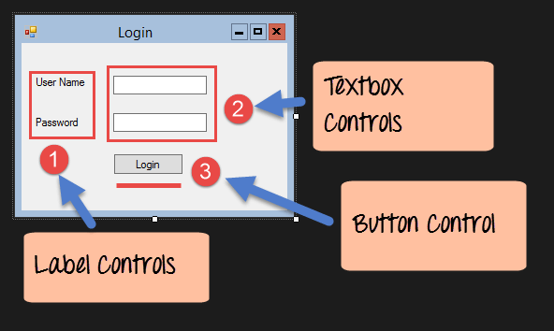
So an example of the controls available in the above application
- This is a collection of label controls which are normally used to describe adjacent controls. So in our case, we have 2 textboxes, and the labels are used to tell the user that one textbox is for entering the user name and the other for the password.
- The 2 textboxes are used to hold the username and password which will be entered by the user.
- Finally, we have the button control. The button control will normally have some code attached to perform a certain set of actions. So for example in the above case, we could have the button perform an action of validating the user name and password which is entered by the user.

C# Hello World
Now let's look at an example of how we can implement a simple 'hello world' application in Visual Studio. For this, we would need to implement the below-mentioned steps
Step 1) The first step involves the creation of a new project in Visual Studio. After launching Visual Studio, you need to choose the menu option New->Project.
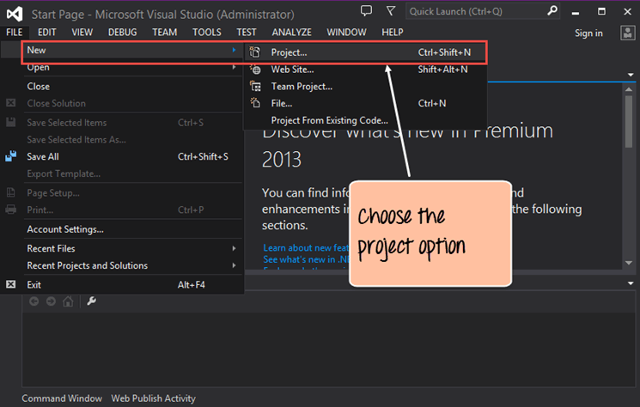
Step 2) The next step is to choose the project type as a Windows Forms application. Here we also need to mention the name and location of our project.
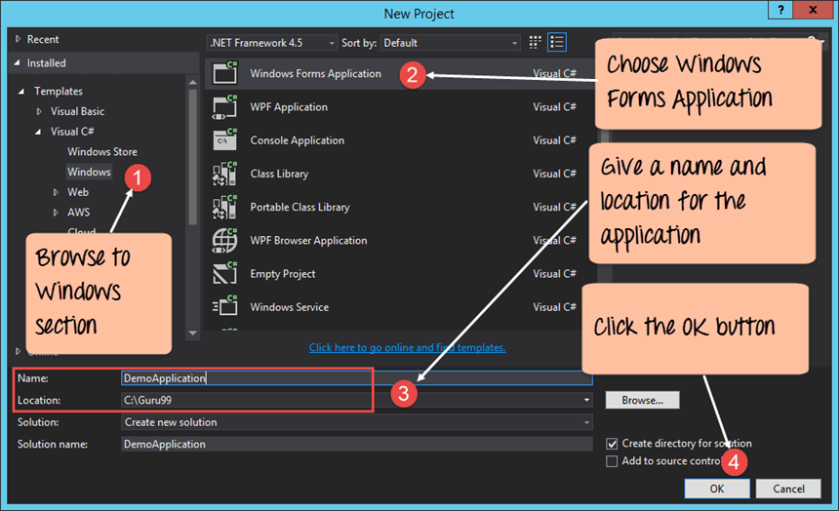
- In the project dialog box, we can see various options for creating different types of projects in Visual Studio. Click the Windows option on the left-hand side.
- When we click the Windows options in the previous step, we will be able to see an option for Windows Forms Application. Click this option.
- We then give a name for the application which in our case is DemoApplication. We also need to provide a location to store our application.
- Finally, we click the 'OK' button to let Visual Studio create our project.
If the above steps are followed, you will get the below output in Visual Studio.
Output:-
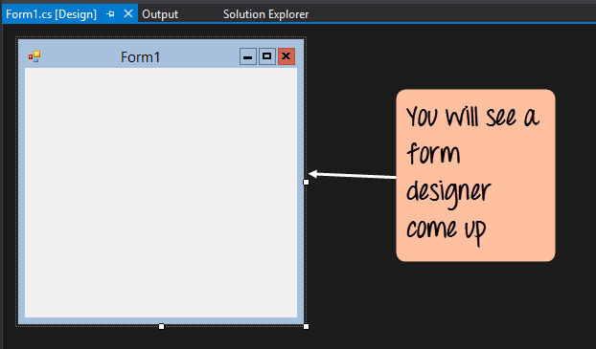
You will see a Form Designer displayed in Visual Studio. It's in this Form Designer that you will start building your Windows Forms application.
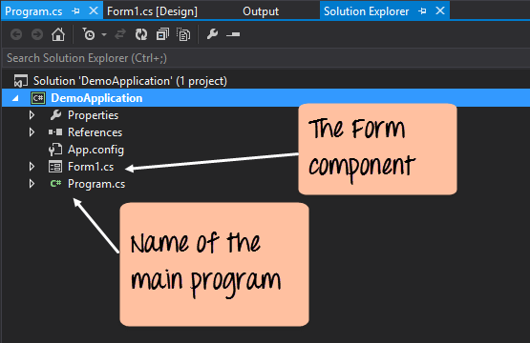
In the Solution Explorer, you will also be able to see the DemoApplication Solution. This solution will contain the below 2 project files
- A Form application called Forms1.cs. This file will contain all of the code for the Windows Form application.
- The Main program called Program.cs is default code file which is created when a new application is created in Visual Studio. This code will contain the startup code for the application as a whole.
On the left-hand side of Visual Studio, you will also see a ToolBox. The toolbox contains all the controls which can be added to a Windows Forms. Controls like a text box or a label are just some of the controls which can be added to a Windows Forms.
Below is a screenshot of how the Toolbox looks like.
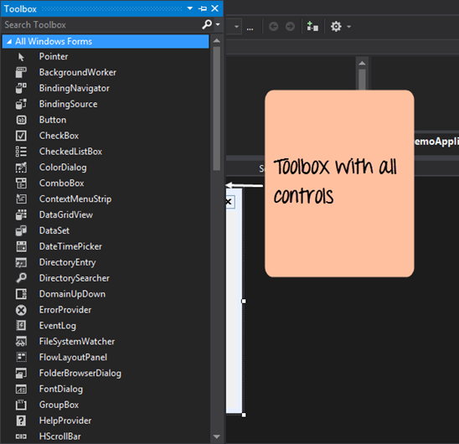
Step 3) In this step, we will now add a label to the Form which will display "Hello World." From the toolbox, you will need to choose the Label control and simply drag it onto the Form.
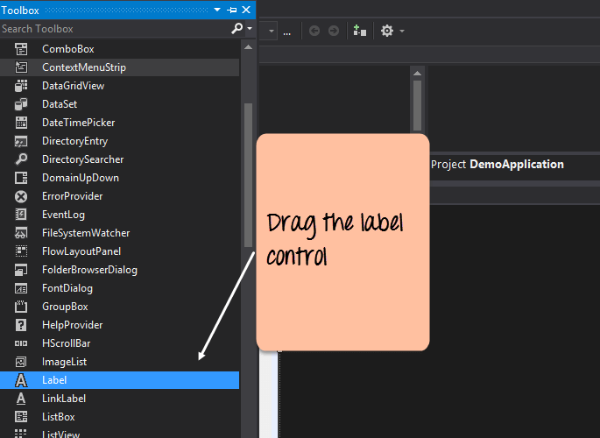
Once you drag the label to the form, you can see the label embedded on the form as shown below.
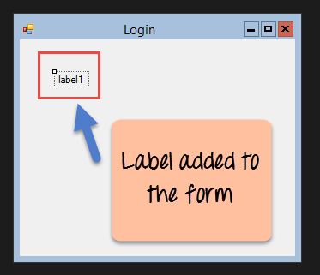
Step 4) The next step is to go to the properties of the control and Change the text to 'Hello World'.
To go to the properties of a control, you need to right-click the control and choose the Properties menu option
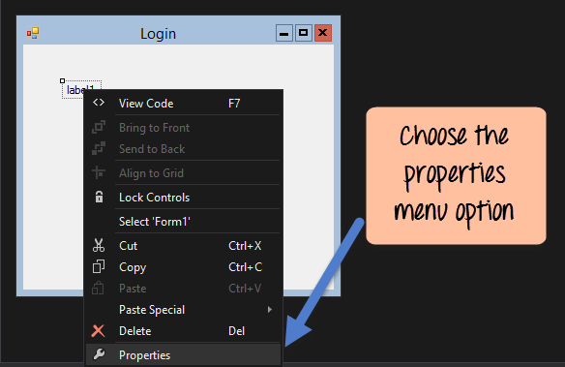
- The properties panel also shows up in Visual Studio. So for the label control, in the properties control, go to the Text section and enter "Hello World".
- Each Control has a set of properties which describe the control.
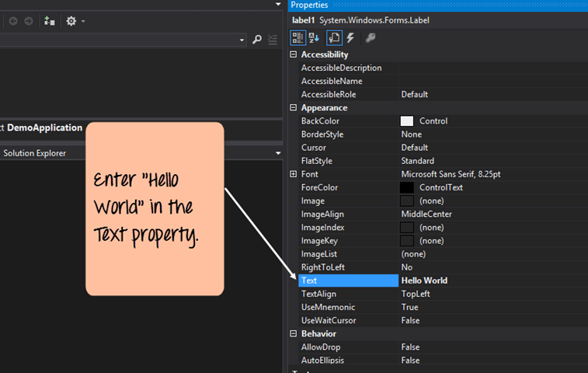
If you follow all of the above steps and run your program in Visual Studio, you will get the following output
Output:-
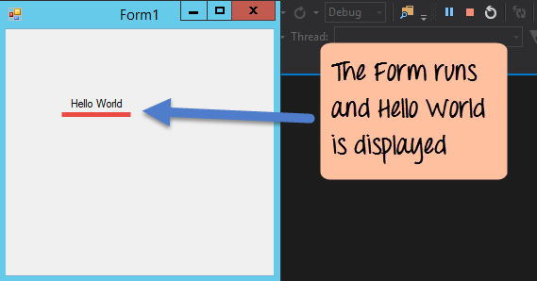
In the output, you can see that the Windows Form is displayed. You can also see 'Hello World' is displayed on the form.

Adding Controls to a form
We had already seen how to add a control to a form when we added the label control in the earlier section to display "Hello World."
Let's look at the other controls available for Windows forms and see some of their common properties.
In our example, we will create one form which will have the following functionality.
- The ability for the user to enter name and address.
- An option to choose the city in which the user resides in
- The ability for the user to enter an option for the gender.
- An option to choose a course which the user wants to learn. There will make choices for both C# and ASP.Net
So let's look at each control in detail and add them to build the form with the above-mentioned functionality.

Group Box
A group box is used for logical grouping controls into a section. Let's take an example if you had a collection of controls for entering details such as name and address of a person. Ideally, these are details of a person, so you would want to have these details in a separate section on the Form. For this purpose, you can have a group box. Let's see how we can implement this with an example shown below
Step 1) The first step is to drag the Groupbox control onto the Windows Form from the toolbox as shown below
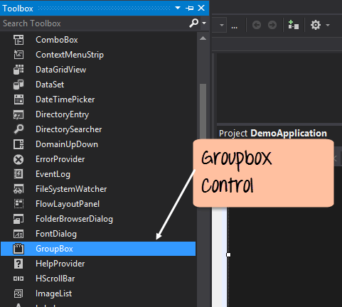
Step 2) Once the groupbox has been added, go to the properties window by clicking on the groupbox control. In the properties window, go to the Text property and change it to "User Details".
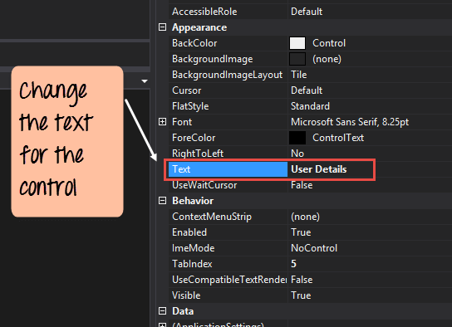
Once you make the above changes, you will see the following output
Output:-
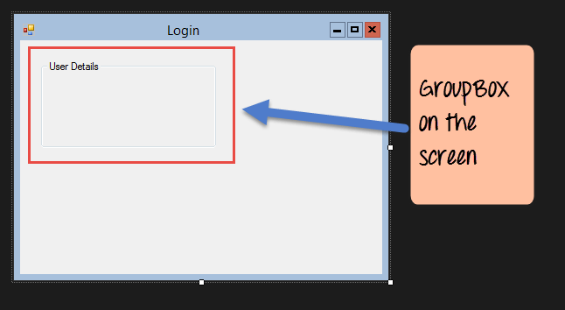
In the output, you can clearly see that the Groupbox was added to the form. You can also see that the text of the groupbox was changed to "User Details."

Label Control
Next comes the Label Control. The label control is used to display a text or a message to the user on the form. The label control is normally used along with other controls. Common examples are wherein a label is added along with the textbox control.
The label indicates to the user on what is expected to fill up in the textbox. Let's see how we can implement this with an example shown below. We will add 2 labels, one which will be called 'name' and the other called 'address.' They will be used in conjunction with the textbox controls which will be added in the later section.
Step 1) The first step is to drag the label control on to the Windows Form from the toolbox as shown below. Make sure you drag the label control 2 times so that you can have one for the 'name' and the other for the 'address'.
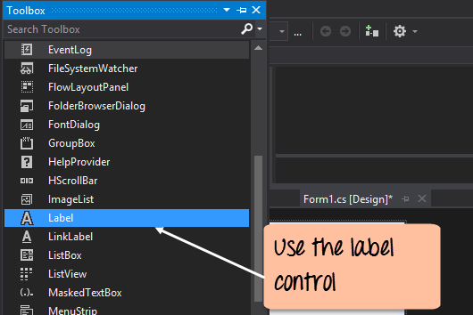
Step 2) Once the label has been added, go to the properties window by clicking on the label control. In the properties window, go to the Text property of each label control.
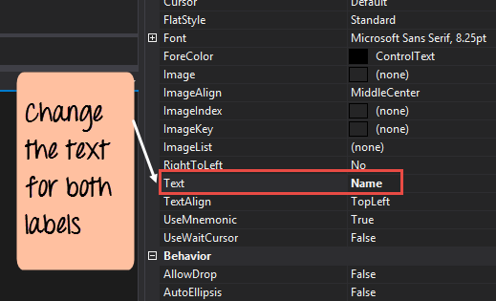
Once you make the above changes, you will see the following output
Output:-
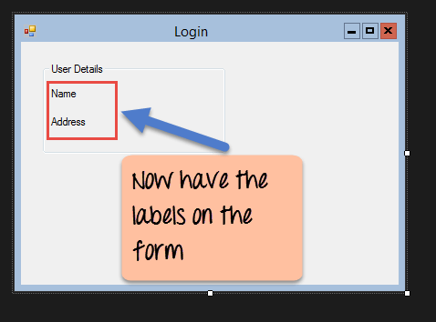
You can see the label controls added to the form.

Textbox
A textbox is used for allowing a user to enter some text on the forms application. Let's see how we can implement this with an example shown below. We will add 2 textboxes to the form, one for the Name and the other for the address to be entered for the user
Step 1) The first step is to drag the textbox control onto the Windows Form from the toolbox as shown below
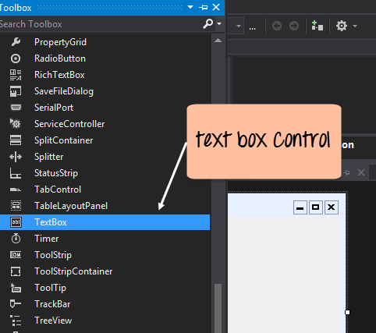
Step 2) Once the text boxes have been added, go to the properties window by clicking on the textbox control. In the properties window, go to the Name property and add a meaningful name to each textbox. For example, name the textbox for the user as txtUser and that for the address as txtAddress. A naming convention and standard should be made for controls because it becomes easier to add extra functionality to these controls, which we will see later on.
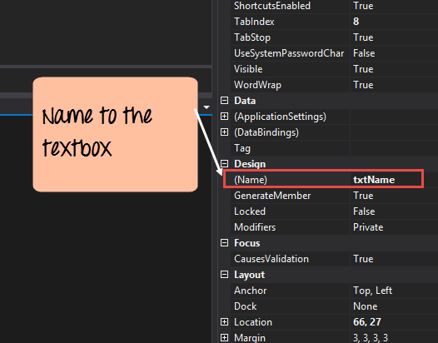
Once you make the above changes, you will see the following output
Output:-
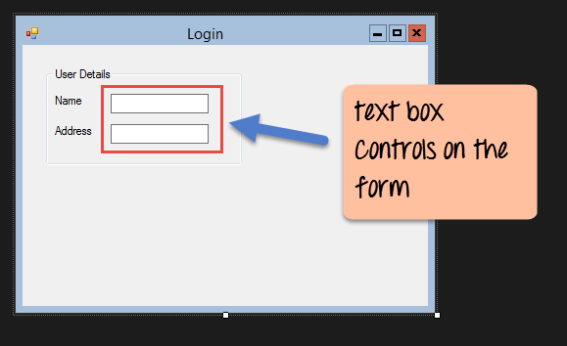
In the output, you can clearly see that the Textboxes was added to the form.

List box
A Listbox is used to showcase a list of items on the Windows form. Let's see how we can implement this with an example shown below. We will add a list box to the form to store some city locations.
Step 1) The first step is to drag the list box control onto the Windows Form from the toolbox as shown below
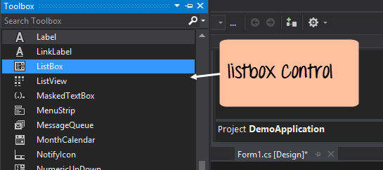
Step 2) Once the list box has been added, go to the properties window by clicking on the list box control.
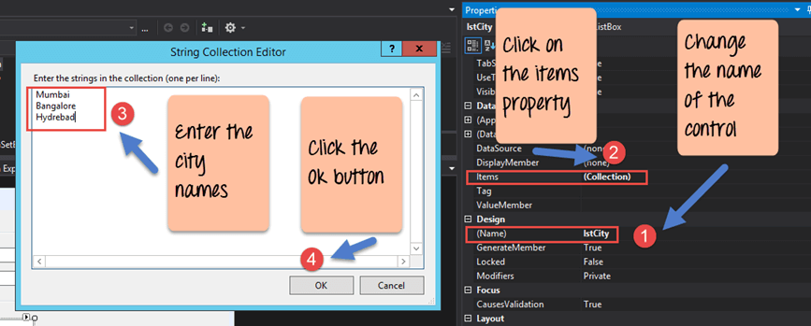
- First, change the property of the Listbox box control, in our case, we have changed this to lstCity
- Click on the Items property. This will allow you to add different items which can show up in the list box. In our case, we have selected items "collection".
- In the String Collection Editor, which pops up, enter the city names. In our case, we have entered "Mumbai", "Bangalore" and "Hyderabad".
- Finally, click on the 'OK' button.
Once you make the above changes, you will see the following output
Output:-
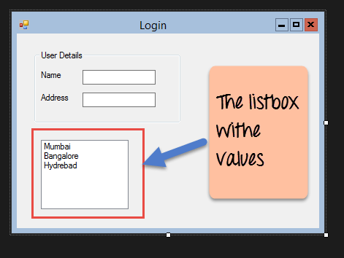
In the output, you can see that the Listbox was added to the form. You can also see that the list box has been populated with the city values.

RadioButton
A Radiobutton is used to showcase a list of items out of which the user can choose one. Let's see how we can implement this with an example shown below. We will add a radio button for a male/female option.
Step 1) The first step is to drag the 'radiobutton' control onto the Windows Form from the toolbox as shown below.
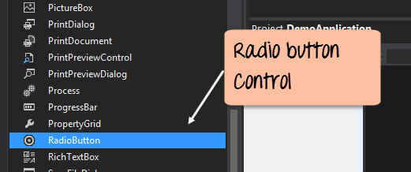
Step 2) Once the Radiobutton has been added, go to the properties window by clicking on the Radiobutton control.
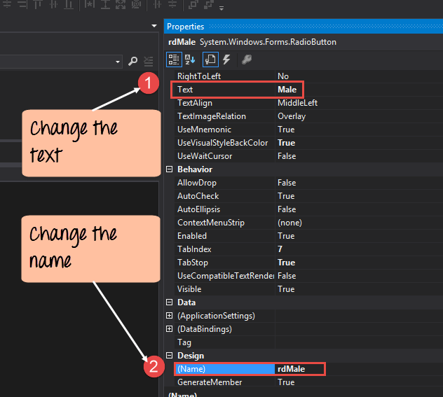
- First, you need to change the text property of both Radio controls. Go the properties windows and change the text to a male of one radiobutton and the text of the other to female.
- Similarly, change the name property of both Radio controls. Go the properties windows and change the name to 'rdMale' of one radiobutton and to 'rdfemale' for the other one.
One you make the above changes, you will see the following output
Output:-
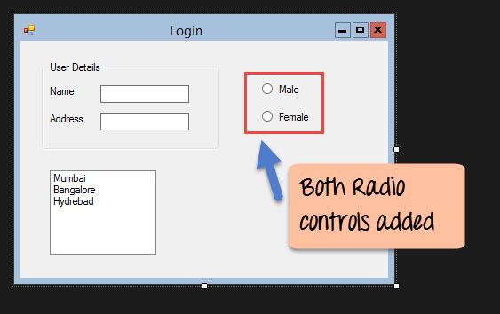
You will see the Radio buttons added to the Windows form.

Checkbox
A checkbox is used to provide a list of options in which the user can choose multiple choices. Let's see how we can implement this with an example shown below. We will add 2 checkboxes to our Windows forms. These checkboxes will provide an option to the user on whether they want to learn C# or ASP.Net.
Step 1) The first step is to drag the checkbox control onto the Windows Form from the toolbox as shown below
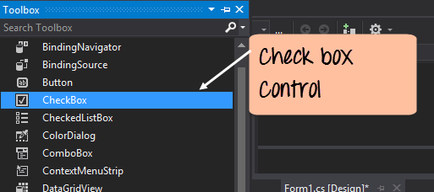
Step 2) Once the checkbox has been added, go to the properties window by clicking on the Checkbox control.
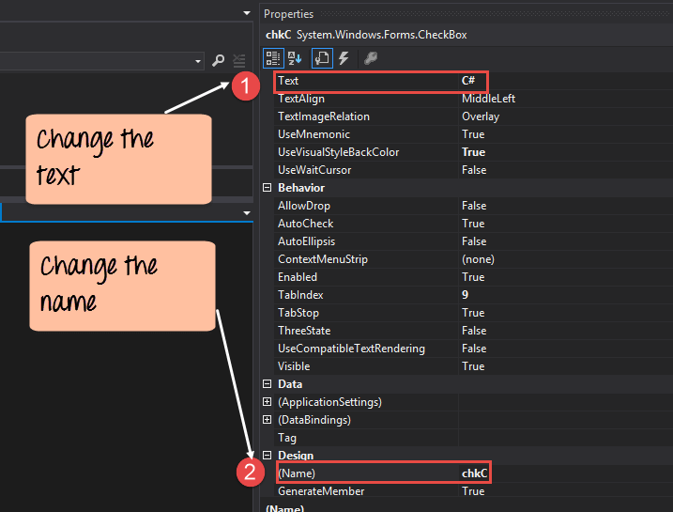
In the properties window,
- First, you need to change the text property of both checkbox controls. Go the properties windows and change the text to C# and ASP.Net.
- Similarly, change the name property of both Radio controls. Go the properties windows and change the name to chkC of one checkbox and to chkASP for the other one.
Once you make the above changes, you will see the following output
Output:-
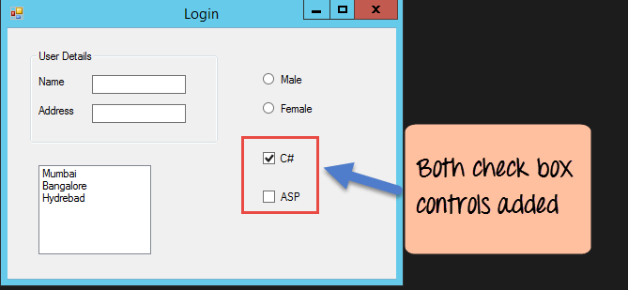

Button
A button is used to allow the user to click on a button which would then start the processing of the form. Let's see how we can implement this with an example shown below. We will add a simple button called 'Submit' which will be used to submit all the information on the form.
Step 1) The first step is to drag the button control onto the Windows Form from the toolbox as shown below
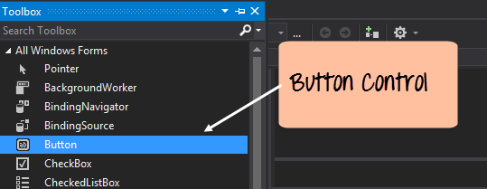
Step 2) Once the Button has been added, go to the properties window by clicking on the Button control.
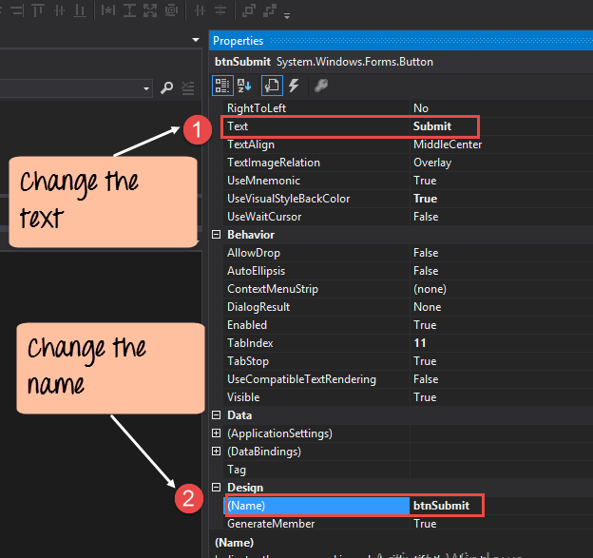
- First, you need to change the text property of the button control. Go the properties windows and change the text to 'submit'.
- Similarly, change the name property of the control. Go the properties windows and change the name to 'btnSubmit'.
Once you make the above changes, you will see the following output
Output:-
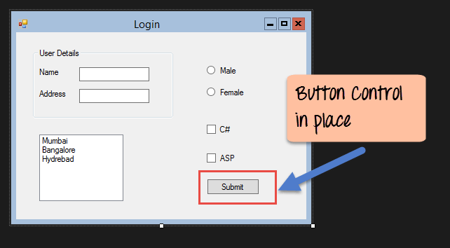
Congrats, you now have your first basic Windows Form in place. Let's now go to the next topic to see how we can do Event handling for Controls.

C# Event Handling for Controls
When working with windows form, you can add events to controls. An event is something that happens when an action is performed. Probably the most common action is the clicking of a button on a form. In Windows Forms, you can add code which can be used to perform certain actions when a button is pressed on the form.
Normally when a button is pressed on a form, it means that some processing should take place.
Let's take a look at one of the event and how it can be handled before we go to the button event scenario.
The below example will showcase an event for the Listbox control. So whenever an item is selected in the listbox control, a message box should pop up which shows the item selected. Let's perform the following steps to achieve this.
Step 1) Double click on the Listbox in the form designer. By doing this, Visual Studio will automatically open up the code file for the form. And it will automatically add an event method to the code. This event method will be triggered, whenever any item in the listbox is selected.
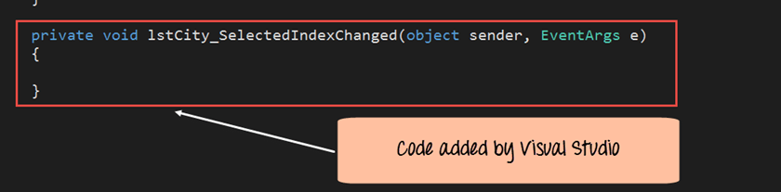
Above is the snippet of code which is automatically added by Visual Studio, when you double-click the List box control on the form. Now let's add the below section of code to this snippet of code, to add the required functionality to the listbox event.
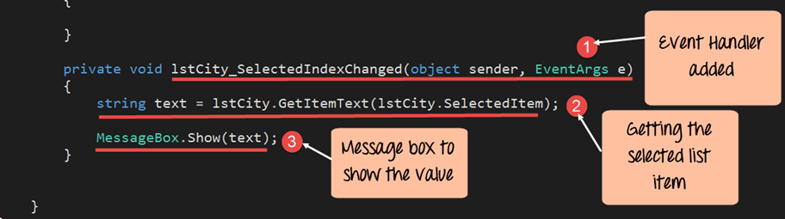
- This is the event handler method which is automatically created by Visual Studio when you double-click the List box control. You don't need to worry about the complexity of the method name or the parameters passed to the method.
- Here we are getting the SelectedItem through the lstCity.SelectedItem property. Remember that lstCity is the name of our Listbox control. We then use the GetItemText method to get the actual value of the selected item. We then assign this value to the text variable.
- Finally, we use the MessageBox method to display the text variable value to the user.
One you make the above changes, and run the program in Visual Studio you will see the following output
Output:-
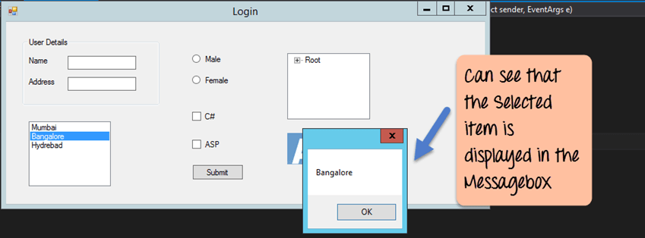
From the output, you can see that when any item from the list box is selected, a message box will pops up. This will show the selected item from the listbox.
Now let's look at the final control which is the button click Method. Again this follows the same philosophy. Just double click the button in the Forms Designer and it will automatically add the method for the button event handler. Then you just need to add the below code.
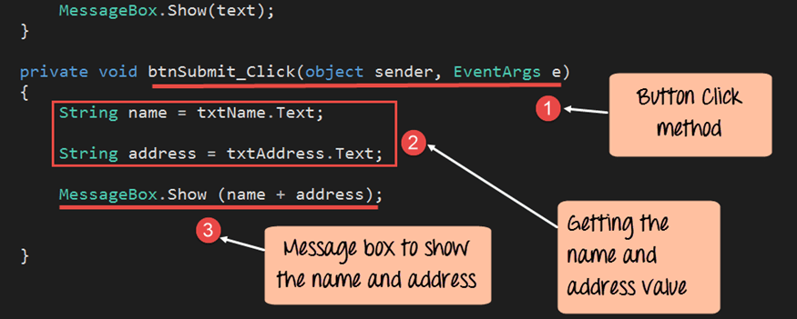
- This is the event handler method which is automatically created by Visual Studio when you double click the button control. You don't need to worry on the complexity of the method name or the parameters passed to the method.
- Here we are getting values entered in the name and address textbox. The values can be taken from the text property of the textbox. We then assign the values to 2 variables, name, and address accordingly.
- Finally, we use the MessageBox method to display the name and address values to the user.
One you make the above changes, and run the program in Visual Studio you will see the following output
Output:-
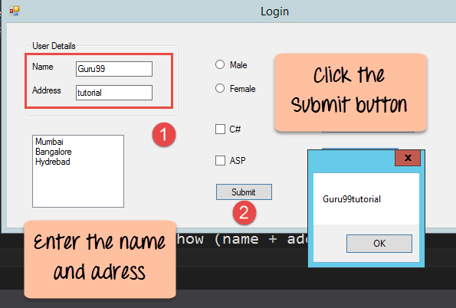
- First, enter a value in the name and address field.
- Then click on the Submit button
Once you click the Submit button, a message box will pop, and it will correctly show you what you entered in the user details section.

Tree and PictureBox Control
There are 2 further controls we can look at, one is the 'Tree Control' and the other is the 'Image control'. Let's look at examples of how we can implement these controls

Tree Control
– The tree control is used to list down items in a tree like fashion. Probably the best example is when we see the Windows Explorer itself. The folder structure in Windows Explorer is like a tree-like structure.
Let's see how we can implement this with an example shown below.
Step 1) The first step is to drag the Tree control onto the Windows Form from the toolbox as shown below
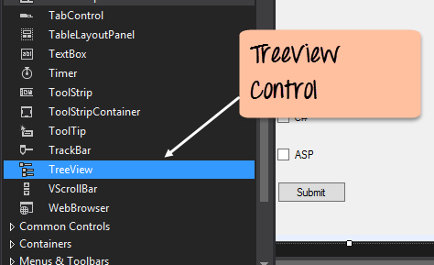
Step 2) The next step is to start adding nodes to the tree collection so that it can come up in the tree accordingly. First, let's follow the below sub-steps to add a root node to the tree collection.
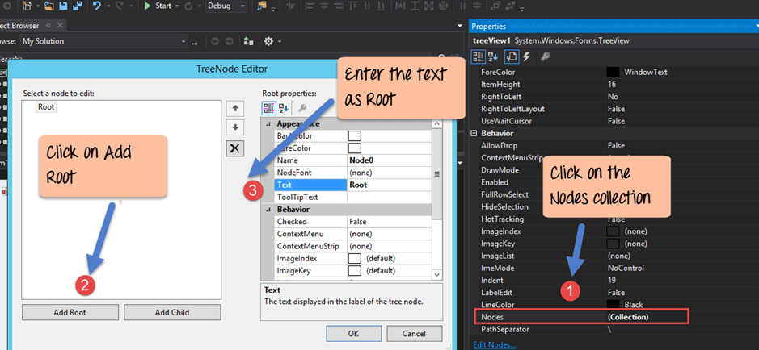
- Go to the properties toolbox for the tree view control. Click on the Node's property. This will bring up the TreeNode Editor
- In the TreeNode Editor click on the Add Root button to add a root node to the tree collection.
- Next, change the text of the Root node and provide the text as Root and click 'OK' button. This will add Root node.
Step 3) The next step is to start adding the child nodes to the tree collection. Let's follow the below sub-steps to add child root node to the tree collection.
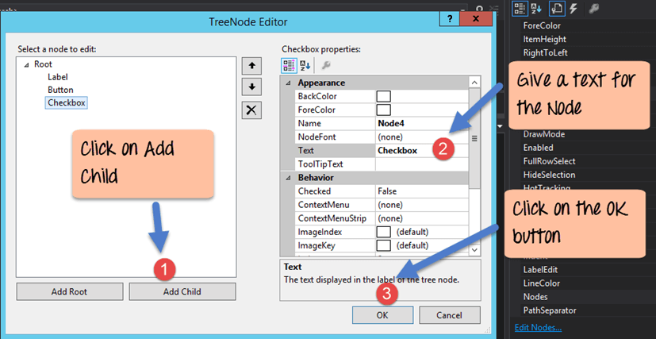
- First, click on the Add child button. This will allow you to add child nodes to the Tree collection.
- For each child node, change the text property. Keep on repeating the previous step and this step and add 2 additional nodes. In the end, you will have 3 nodes as shown above, with the text as Label, Button, and Checkbox respectively.
- Click on the OK button
Once you have made the above changes, you will see the following output.
Output:-
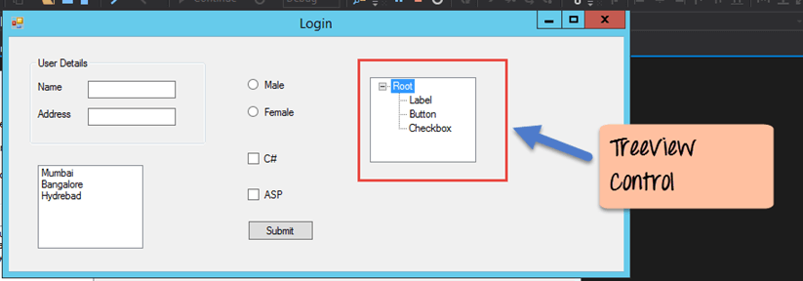
You will be able to see the Tree view added to the form. When you run the Windows form application, you can expand the root node and see the child nodes in the list.

PictureBox Control
This control is used to add images to the Windows Forms. Let's see how we can implement this with an example shown below.
Step 1) The first step is to drag the PictureBox control onto the Windows Form from the toolbox as shown below
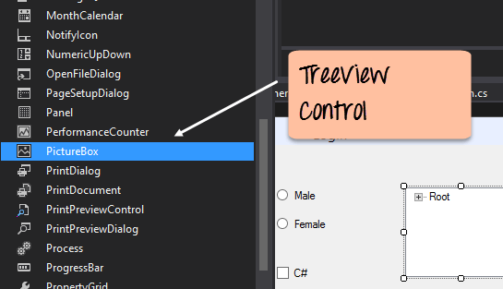
Step 2) The next step is to actually attach an image to the picture box control. This can be done by following the below steps.
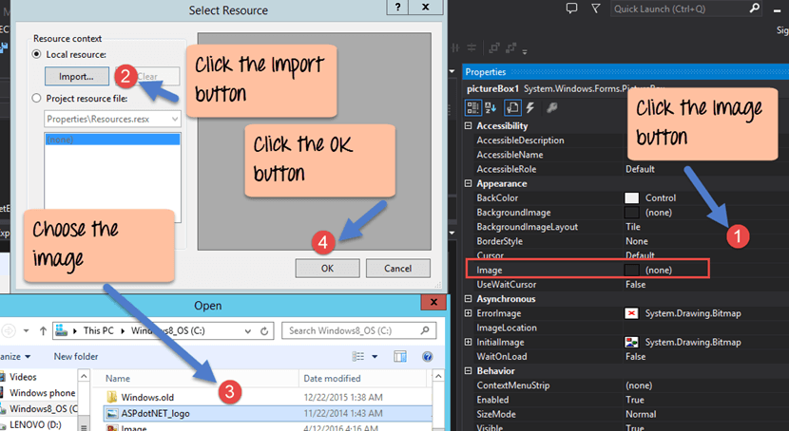
- First, click on the Image property for the PictureBox control. A new window will pops out.
- In this window, click on the Import button. This will be used to attach an image to the picturebox control.
- A dialog box will pop up in which you will be able to choose the image to attach the picturebox
- Click on the OK button
One you make the above changes, you will see the following output
Output:-
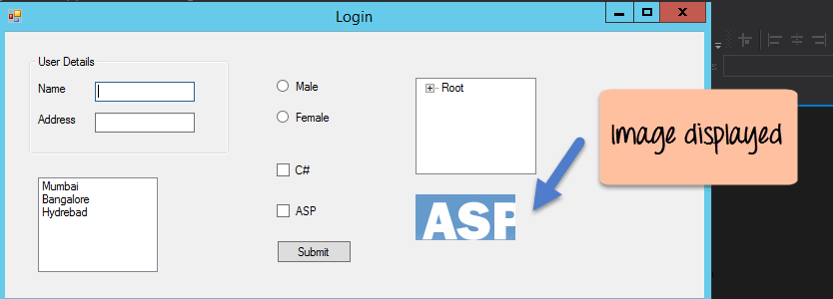
From the output, you can see that an image is displayed on the form.

